1)PSEUDOCODE:
START
Read date (dd/mm/yyyy)
Extract year
IF (year % 400 == 0) OR (year % 4 == 0 AND year % 100 != 0)
Print "Leap Year"
ELSE
Print "Non Leap Year"
END IF
STOP
OUTPUT:
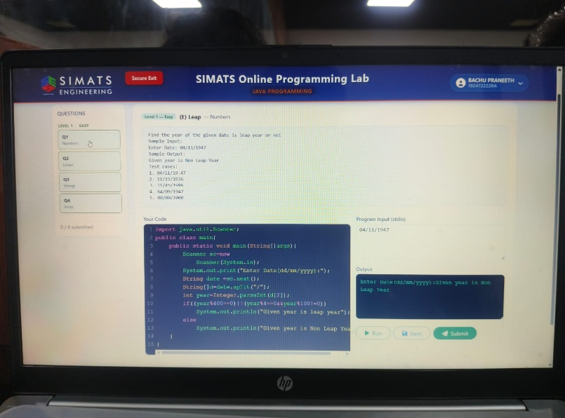
2)PSEUDOCODE:
START
Read symbol
FOR i = 1 to 4
FOR j = 1 to 5
Print symbol
END FOR
Print new line
END FOR
STOP
OUTPUT:
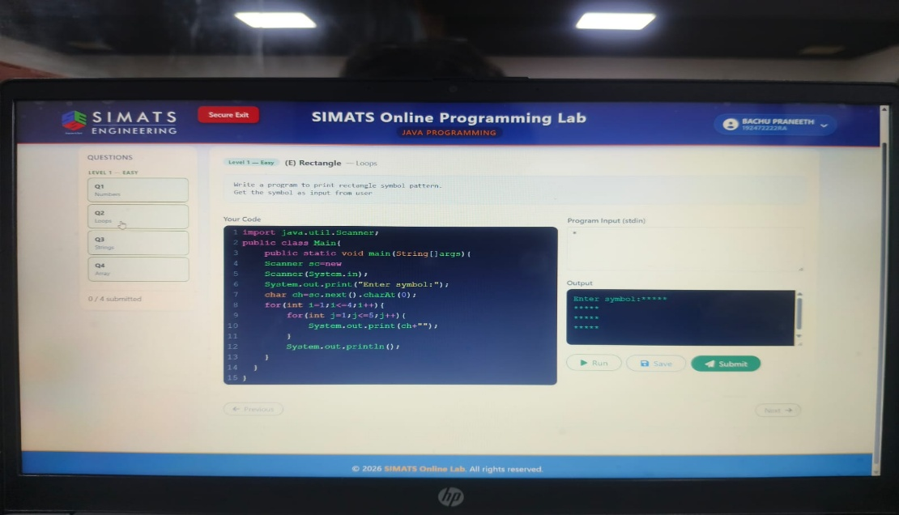
3)PSEUDOCODE:
START
Read string
FOR i = length-1 to 0
Print string[i]
END FOR
STOP
OUTPUT:
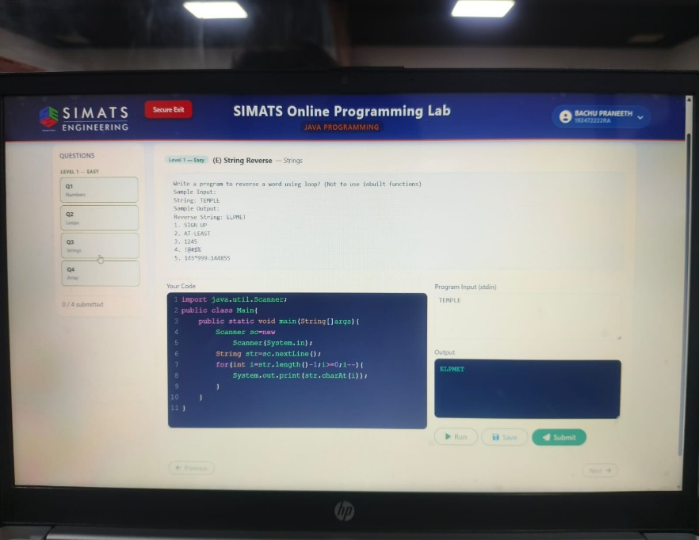
4)PSEUDOCODE:
START
Read n
Read n array elements
Find sum
Mean = sum / n
Sort the array
Median = middle element
Find the element with maximum frequency
Mode = most repeated element
Print Mean, Median and Mode
STOP
OUTPUT:
